Housing Affordability Crisis in Canada

Ashley Miller and Durva Parmar
University of Northern British Columbia
ECON 204: Contemporary Economic Issues
Professor Muhebullah Karimzada
March 31, 2025

The Housing Market Affordability Crisis
The housing affordability crisis is a growing global phenomenon. Cities around the world are experiencing unprecedented housing cost increases, which is contributing to a decline in the standard of living. This issue proves true in Canada, with cities such as Vancouver and Toronto ranking third and eleventh for the least affordable English-speaking markets in 2023 (Demographia, 2024). In less populated communities, such as Prince George, the average selling price rose by over $80,000, from 2019 to 2021, and saw an almost 20% increase in sales (VMDC, 2022). This poses significant concerns for the well-being of those who struggle to access this basic human need, underscoring the important role of the local and federal government in establishing policies to protect such vulnerable members of society.
Many factors influence the housing affordability crisis. In Canada, COVID-19 was responsible for considerable market disruption. This was seen through a construction disruption and change in consumer buying behaviour. Additionally, the Bank of Canada’s monetary policies play a significant role in consumer borrowing habits. In response to COVID-19, the Bank of Canada imposed historically low interest rates, boosting overall housing market demand. Furthermore, immigration played its part by placing additional stress on the already imbalanced market. This imbalance can be partially attributed to reduced supply due to stringent zoning regulations and workflow disruption. Altogether, these factors contributed to Canada’s housing affordability crisis. In response to this current crisis, the Canadian government must impose effective and efficient policies to ensure that this basic human need is met for all members of society.
The Impact of COVID-19
In 2020, the global pandemic caused considerable disruption to the housing market. This outcome was seen not only in Canada but across the world. Significant variables contributing to the COVID-19 disruption include a cross-industry production and supply chain interference. 60% of Canadian builders reported supply change issues, which in turn translated to higher costs and wait times. Additionally, in 2021, over 40% of builders reported delaying pre-sale and developments due to price volatility (Housing Market Index, 2025). In British Columbia, labour shortages in 2020, cause further issues, affecting 50% of contractors across the province (ICBA, 2021).
Another notable effect was a change in consumer buying behaviour. Prior to 2020, most individuals were restrained by geographical requirements such as work, school, or other commitments. However, as COVID-19 escalated to a global pandemic, the percentage of Canadians working from home rose by almost 33% (Morissette, 2024). This increase in remote work led buyers to require more space. Individuals shifting to remote work or schooling now required an at home office. Additionally, consumers were no longer limited by geographical restraints, which led to consumers buying housing in locations that were previously not an option. Another factor contributing to a change in buying behavior was a shift in self-reliance and social distancing practices all leading to a change in consumer needs and buying patterns.
Additionally, the change in consumer buying behaviour put more pressure on the housing market. With an increased demand and a decrease in supply, the housing market was imbalanced creating higher prices consumers were willing to pay with a shortage. Furthermore, the average dollar value homeowners expected to see when selling their home increased by over 40% from 2016 to 2021 (Government of Canada, Statistics Canada, 2023). Refer to Appendix A to view chart. COVID-19 cause significant disruptions to the housing market, with less home available and increased demand, prices skyrocketed. This raised significant concerns as this basic human need becomes less accessible. It is imperative that governments implement proactive policies to mitigate potential consequences.
The Impact of Immigration
The impact of immigration on Canada’s housing affordability crisis is not without merit. In 2023, Statistics Canada, reported a total population increase of permanent and non-permanent nearly 1,160,000. This was a 2.9% increase from the previous year, which was the highest population growth recorded since the 1950’s (CBC/Radio Canada, 2024). In 2025, the Canadian government aims to increase new immigrants by 500,000 (Press, 2023). Without an adequate increase in housing options available, both Canadian’s and immigrants are feeling the impact of an unbalance housing market. This is particularly concerning, as individuals making their way over to Canada will undoubtably be impacted by this ongoing crisis. To support sustainable immigration practices, the federal government must manage the flow of immigration responsible. This is to support the housing needs of all individuals residing in Canada.
The Current Impact of High Housing Rates
These days families are facing significant pressure on household expenses. Nowadays, bills for essentials, such as electricity, water, and other types of taxes are rising, making it difficult for individuals to make ends meet. Getting behind on food and other basic expenses is getting too common for people (MNP Debt, 2024). People are coming up with new innovative ideas like sharing rides buying in bulk and even living together to cut costs. Additionally, as thing have become so serious more people are using food banks and now about 21% of those relying on these services are two parent households, which is a noticeable jump, compared to previous years (CTV News, 2024). This outcome created a costing sky, where people were hoping for a financial bounce back after COVID-19 however it got even worse than before with inflation and rising interest rates. Families found themselves struggling again and at first while panda makeover, support, and assistance checks helped ease the burden (Global news, 2024). Currently as we work towards recovering from the pandemic, we are encountering fresh issues related to social welfare rates and concerns about wages in certain areas (The Sun, 2024). In addition, mortgage rates have risen, making it hard for me class families to afford a home(news.com.au,2024). Overall, financial difficulties for households haven’t really eased up since the pandemic with inflation, rising interest rates and stagnant wages. Many families are finding it tough to make ends meet. This situation is pushing them to cut back on little luxuries delay, delay, significant life changes and reconsider their long-term financial plans.
The Impact of Monetary Policy
The Bank of Canada's decisions regarding interest rates significantly shapes the Canadian housing market. This is true both before, during, and in the aftermath of the COVID-19 pandemic. Before 2020, the Bank increased interest rates in 2017 to try and cool down the hot housing market, especially in places like Toronto and Vancouver. Even though higher rates made mortgages pricier, housing prices kept climbing because demand was strong, and supply was limited. Moreover, when mortgage stress tests were rolled out in 2018, buyers had to qualify at higher rates, which reduced their purchasing power and slowed down sales. Still, the issue of affordability continued to be a struggle for many.
When the COVID-19 pandemic hit, the Bank of Canada drastically cut interest rates to a historic low of 0.25% in March 2020 to boost the economy. These emergency cuts made mortgages more affordable and boosted housing demand, especially in suburban and rural areas. On top of that, the central bank's quantitative easing policies added liquidity to the financial system, which greatly helped home sales take off and increased market competition (The Bank of Canada, n.d.). During this time, home prices skyrocketed as buyers rushed to take advantage of those low borrowing costs. After the pandemic, the Bank of Canada changed gears by aggressively raising interest rates starting in 2022 to fight inflation, reaching 5.00% by 2023. These hikes considerably raised mortgage costs, slowing down demand but not really bringing down home prices, mainly because of ongoing supply shortages. Even with the higher interest rates, affordability continued to be a big concern, as demand still outstripped available housing. Also, the rising borrowing costs made it harder for new housing projects to get off the ground, since developers faced increased financing costs, further tightening the supply. Experts suggest that while raising interest rates can help stabilize inflation, it’s not enough to fix Canada's deep-rooted housing affordability crisis.
Policy Recommendations
To manage this growing issue policy recommendation is essential. First, it is important to recognize the significance of this basic human need. In Canada, the Charter of Rights and Freedoms, does not list housing as a basic human right. However, there is a growing global perspective that stresses the importance of affordable housing for an individual’s well-being. This perspective is supported by the United Nation, who established the United Nation Human Settlement Program (UN – Habitat) in 2002. This program was implemented to help counties use policies, knowledge, and collaboration to develop sustainable communities (About Us., n.d.). In June of 2019, Canada passed a National Housing Strategy Act, which also acknowledges the social, economic, health, and environmental benefits of affordable housing. These are important steps to pave the way to affordable housing solutions to help all members of society meet their housing needs.
Policy implementation by both local and federal government is essential for managing this ongoing crisis. Several recommendations for increasing housing affordability are to improve zoning regulations and increased trades and skilled workers for the housing workforce. By improving zoning regulations municipal governments can help reduce the barrier to housing construction. In 2023, the BC government introduced Bill 44 that changed zoning bylaws to increase housing supply and affordability. This zoning change allowed for three to four units to be built on single-family lots, which is a step in the right directly (Cranfield, 2024). Additionally, increasing the labour force will help businesses operate efficiently and effectively. Implementing policies to increase supply of housing is one way to address this ongoing issue.
Additionally, other policy recommendations to address this crisis is to lower GST for new homes and manage the flow of immigration to meet the supply of homes. The housing market creates essential revenue streams for the government. However, a governments primary responsibility should always be the best interest of their citizens. In leu of this ongoing crisis the government should reduce GST, as well as HST, on homes, which is reported contribute to as much as 31% of some home’s sales prices (Canadian Chamber of Commerce, 2024). Furthermore, managing the flow of immigration to not exceed the supply of homes is essential. One way to support immigration, as well as the housing market needs, is to project future immigration trends and work to support those needs. Additionally, increasing immigration of skilled trades workers to build homes is another way to manage this ongoing crisis. Policy implementation and management of these key issues is essential for increasing affordability in the housing market. Not only will this support the economic development of Canada, but it will also create healthy and sustainable communities.
Conclusion
The struggle to find affordable housing is a significant issue affecting people all around the world. Prices for homes are skyrocketing at an unprecedented rate, and this is having serious consequences for individuals accessing affordable housing. Significant factors contributing to the Canadian housing crisis encompass the impact of COVI-19, immigration, supply chain disruptions, insufficient work force, and the Bank of Canada’s monetary policies. Each have contributed to significant impact on housing availability and affordability.
Additionally, since the pandemic, many households are still struggling financially due to inflation, rising interest rates, and stagnant wages. Families are finding it increasingly difficult to manage their budgets, leading them to cut back on small luxuries and postpone important life decisions while rethinking their long-term financial plans. Additionally, the rising costs of borrowing are making it tough for new housing projects to launch, as developers face higher financing costs, which further tightens supply. While raising interest rates may help stabilize inflation, it’s clear that it’s not enough to solve Canada’s deepening housing affordability problem. It is imperative that the Canadian government create policies to respond to this crisis to ensure this basic human need is achievable for all.

References
About Us: UN. (n.d.). https://unhabitat.org/about-us
CBC/Radio Canada. (2024, January 21). Linking immigration to the housing shortage may be missing the problem, experts say | CBC news. CBC news. https://www.cbc.ca/news/politics/immigration-housing-crisis-costs-1.7088878
Cranfield, J. (2024, April 29). The province goes big on housing policy – a first look. British Columbia Real Estate Association. https://www.bcrea.bc.ca/advocacy/provincial-housing-policy-summary/#:~:text=On%20November%207%2C%202023%2C%20the,understanding%20of%20housing%20project%20costs
Covid-19: Actions to support the economy and Financial System. Bank of Canada. (n.d.). https://www.bankofcanada.ca/markets/market-operations-liquidity-provision/covid-19-actions-support-economy-financial-system/
CTV News. (2024). More Canadian households struggling to put food on the table due to high cost of living. Retrieved from https://www.ctvnews.ca/canada/more-canadian-households-struggling-to-put-food-on-the-table-due-to-high-cost-of-living-report-1.6616564
Demographia (2024) International Housing Affordability. https://www.demographia.com/dhi.pdf
Global News. (2024). Cost of living crisis impacting families and children's activities. Retrieved from https://globalnews.ca/news/10730717/kids-cost-of-living-inflation-interest-rate-poll
Government can fix the housing affordability crisis - here’s how. Canadian Chamber of Commerce. (2024, December 6). https://chamber.ca/government-can-fix-the-housing-affordability-crisis-heres-how/
Government of Canada, Statistics Canada. (2023, October 4). Focusing on a selected geographic area, this product presents data highlights for each of the major releases of the 2021 census. these data highlights are presented through text, tables and figures. A map image of the geographic area is also included in the product. the geographic levels presented in this product include Canada, provinces and territories, census metropolitan areas, census agglomerations, census divisions and census subdivisions. Focus on Geography Series, 2021 Census - Canada. https://www12.statcan.gc.ca/census-recensement/2021/as-sa/fogs-spg/page.cfm?topic=7&lang=E&dguid=2021A000011124
Housing market index. Canadian Home Builders’ Association. (2025, January 30). https://www.chba.ca/housing-market-index/
ICBA Independent. (2021). https://www.icbaindependent.ca/wp-content/uploads/2020/12/ICBA-Winter-2021-Jan.pdf
MNP Debt. (2024). Rising cost of living forces Canadians to make sacrifices. Retrieved from https://mnpdebt.ca/en/resources/mnp-debt-blog/rising-cost-living-canadians-make-sacrifices
Morissette, R. (2024, January 18). The COVID-19 pandemic led to a substantial increase in work from home in Canada. this presentation synthesizes what has been learned to date regarding this increase in work from home and documents its potential implications for productivity, employee retention, commuting, greenhouse gas emissions, and public transit use. Government of Canada, Statistics Canada. https://www150.statcan.gc.ca/n1/pub/11-631-x/11-631-x2024001-eng.htm
News.com.au. (2024). Mortgage horror exposes financial struggles in Australia. Retrieved from https://www.news.com.au/finance/economy/struggling-mums-viral-admission-reveals-just-how-tough-aussies-are-doing-it/news-story/837b5943787200963363c8a0764011e7
Our covid-19 response: Large-scale asset purchases. Bank of Canada. (n.d.-b). https://www.bankofcanada.ca/2020/08/our-covid-19-response-large-scale-asset-purchases/
Press, T. C. (2023, August 22). Links between housing crisis, immigration must be explored: Miller - National. Global News. https://globalnews.ca/news/9913202/canada-immigration-housing-crunch/
The Sun. (2024). New social welfare rates and wage warnings as cost of living continues to rise. Retrieved from https://www.thesun.ie/money/14860908/social-welfare-rates-wage-warning-fuel-allowance-cut
Vmcdn.ca (January 2022) BC Northern Real Estate Board. https://www.vmcdn.ca/files/princegeorgematters/pgc-files/bcnreb-2021-year-end-news-release.pdf?utm_source=prince%20george%20citizen&utm_campaign=prince%20george%20citizen%3A%20outbound&utm_medium=referral

Appendix A
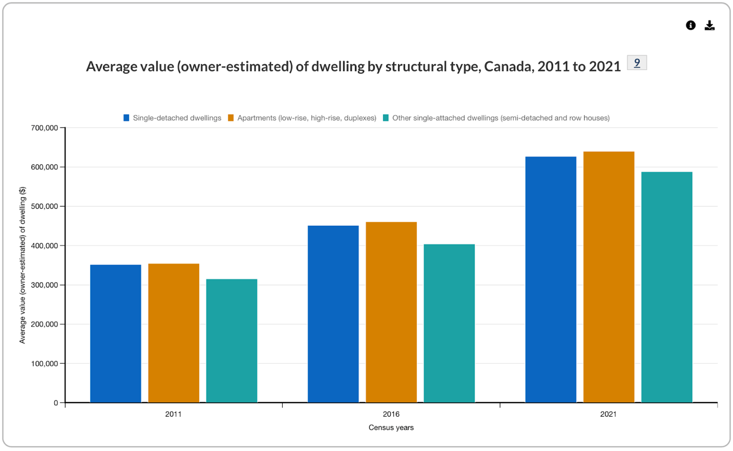
https://www12.statcan.gc.ca/census-recensement/2021/as-sa/fogs-spg/page.cfm?topic=7&lang=E&dguid=2021A000011124

